# **AERO CLUB MNNIT**

# **AVISHKAR 2K20**

# **DRONE AUTOMATION (GUARDIAN)**

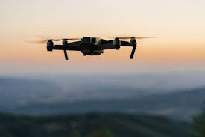 

# **Round: 1**

**Task: 1 (Hexagon In Mission Planner Using DroneKit-Sitl)**

* Connecting with SITL Vehicle on Port : 14551 (mavink)

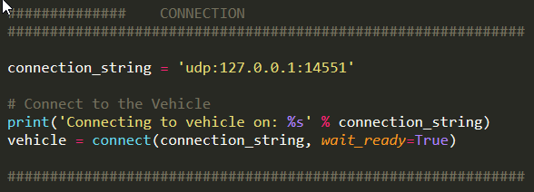

* Function To Move Relatively on Mission Planner

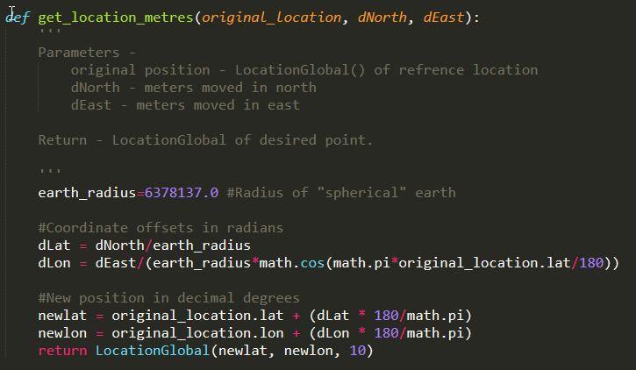

* Defining WavePoints On Mission Planner

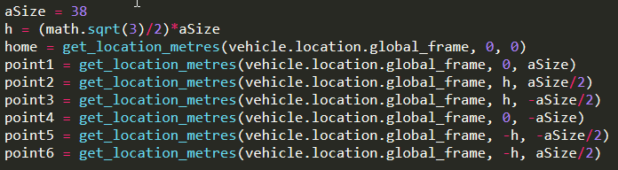

* Arm the SITL vehicle
* Take-off upto recognizable Altitude

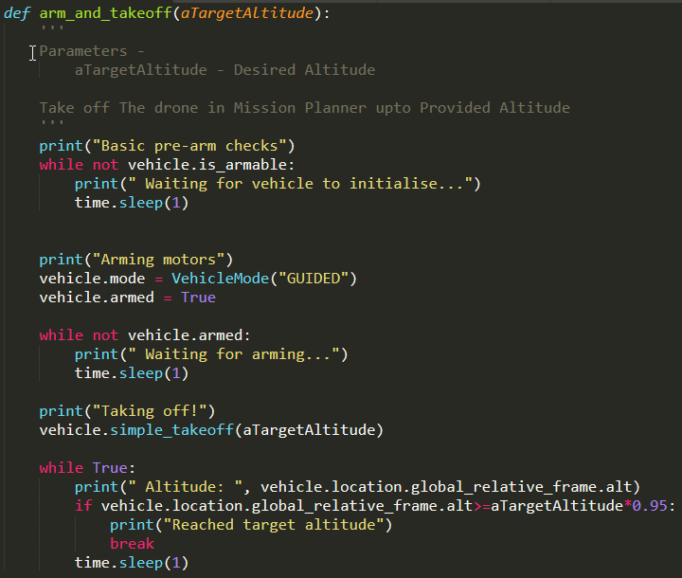

* Adding Defined Wave Points to the mission and upload it to Mission Planner.

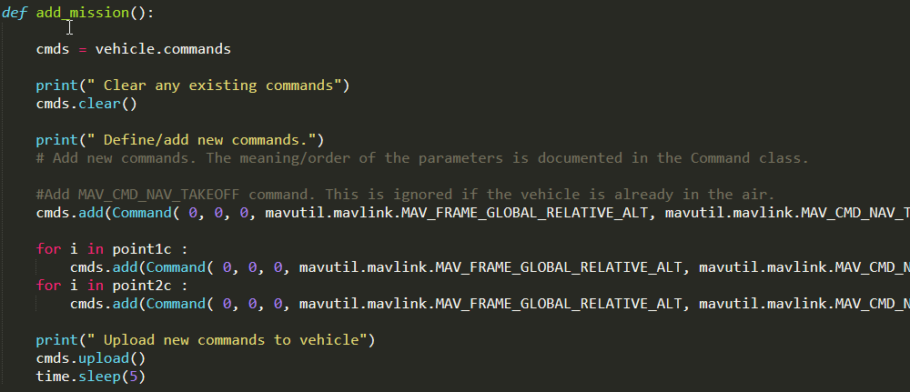

* Main Function which first arm -> take-off -> goto all wave points -> return back to home.

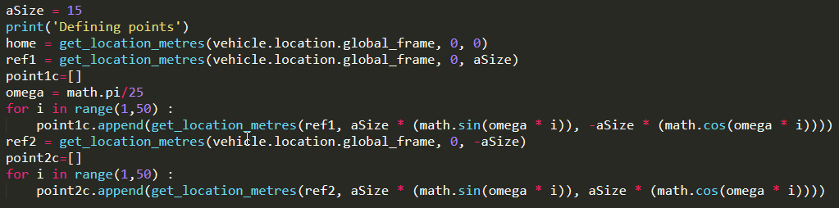

**Task: 2 (8-Figure In Mission Planner Using DroneKit-Sitl)**

* Defining Points (In this case we made 2-Circles with 50 Wave points per circle on a trajectory of Circle. )

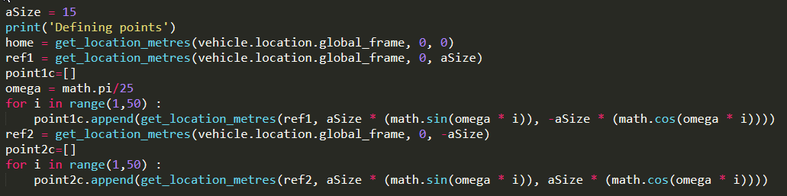

* Main Function

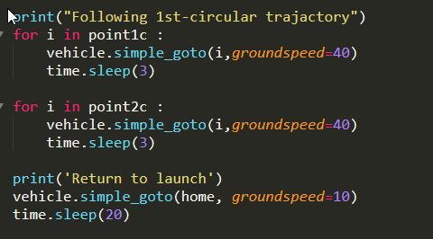

**Task: 3 (Spiral In Mission Planner Using DroneKit-Sitl)**

* Defining Points ( This time We made 3 circles with linearly increasing Radius with rate: )

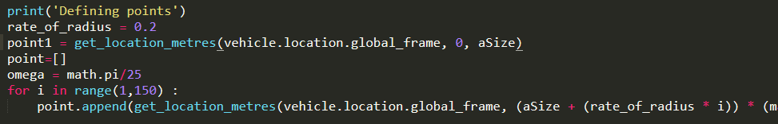

* Main Function

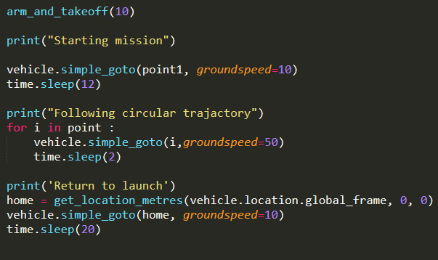

**Task: 4 (Spiral In Mission Planner Using DroneKit-Sitl)**

* Defining Points ( Here We taking X and Z corrdinates on the trajactory of a circle)

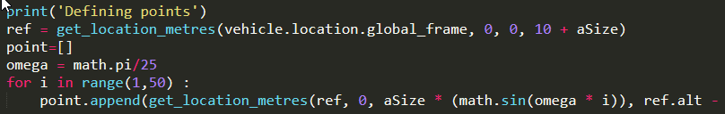

* Main Function

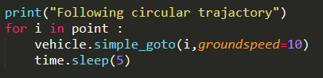

**Task: 5 (Flip In AirSim using airsim API)**

* Main flip function

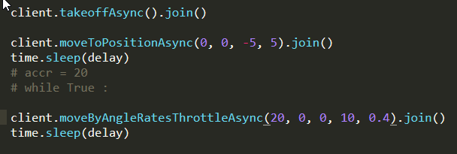

**Task: BONUS (Vertical Circle In AirSim using airsim API)**

* Connection , Arming the Vehicle

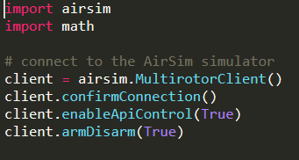

* Defining Points (Similar as in Mission Planner)

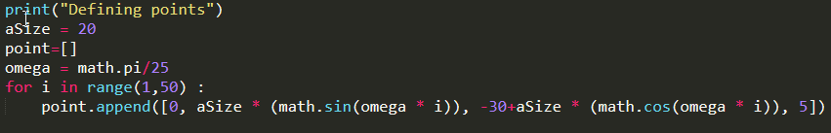

* Take-off -> Following the Wave points -> return to ground

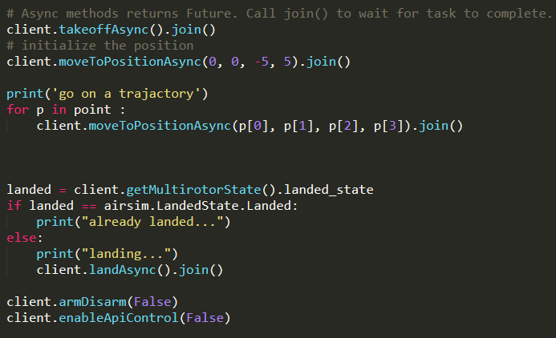

**Task: BONUS (Square In jMAVSim using DroneKit-SITL)**

* Connection jMAVSim using DroneKit-SITL

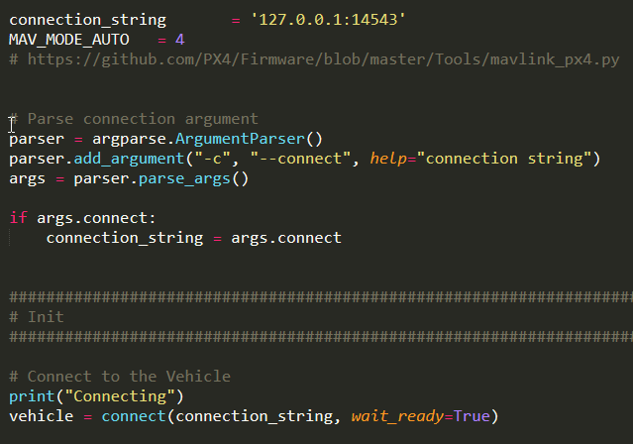

* Setting Copter MODE in jMAVSim

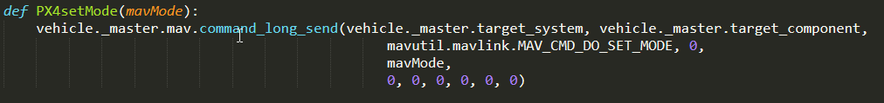

* Getting Information about Copter at its home position

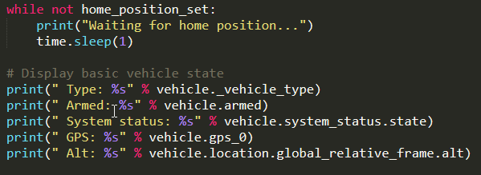

* Setting Mode To ‘AUTO’ and adding Commands to drone

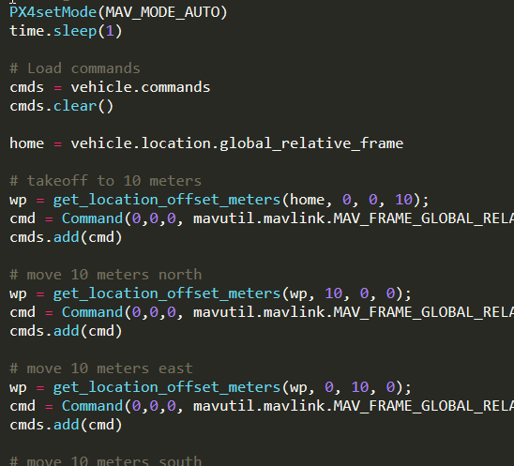

* Armed -> Itreating over the WavePoints -> Disamed

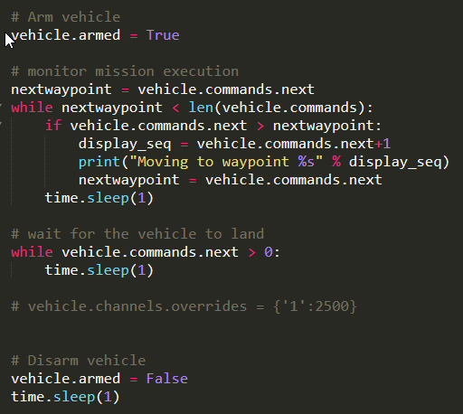

**Task: BONUS (TakeOff In jMAVSim using MAVSDK)**

* Api of MAVSDK

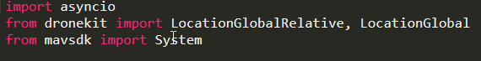

* Connection

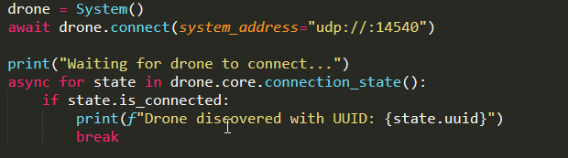

* Arming and Take-off

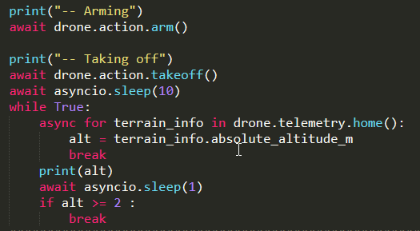

* Main Function

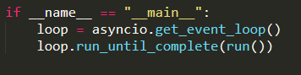

THANK YOU

========================================================

Team Name : K33P_Qu!34

Member 1: Amit Gupta

Member 2: Karimulla Mohd.

GitHub: https://github.com/AmitGupta7580/Drone_Automation

Links of YouTube Videos:

(Task 1) - https://youtu.be/CJ1k0XXFRFI

(Task 2) - <https://youtu.be/uXPIxV_Ehp8>

(Task 3) - <https://youtu.be/z7HnpgHg3Eo>

(Task 4) - <https://youtu.be/1JGODujHMLg>

(BOUNUS TASK) –

(AirSim) : <https://youtu.be/ECzPRfspGp4>

(jMAVSim) :

<https://youtu.be/eHu5aFCIk6I> (take-off) <https://youtu.be/GifM5dBFNbI> (square)

Sorry for that :

Issues With Vedio Recording :

* I am using In built Screen Recode (XBOX) which record screen of one application at one time so , I am not able to show executing the python script
* As I am using Mobile data so, I upload the video in 2x speed.